|  |  |
| --- | --- |
| **Student Number: S10222894** | **Seat Number: NULL** |
| **Student Name: Dominic Lee** | **Module Group: P02** |



**Networking Infrastructure**

Year 2 (2021/22), Semester 3

## School of InfoComm Technology

(Diploma in Cybersecurity & Digital Forensics)

(Diploma in Information Technology)

**COMMON TEST**

Date: 10 June 2021 (Thursday)

Time: 8:30 AM – 10:00 AM

INSTRUCTIONS TO CANDIDATES:

**1. Check carefully to ensure you are sitting for the correct paper.**

2. Write your Student Number, Name, Module Group and Seat Number CLEARLY in the boxes provided.

3. There are FOUR questions. Answer ALL questions.

4. This paper consists of 13 pages including this cover page. Check carefully to make sure your set is complete.

|  |  |
| --- | --- |
| **GRADE** | **A+** |

There are FOUR questions. Answer **ALL** questions.

**QUESTION 1** (20 marks)

You are the network administrator of BAB Company. Figure 1 depicts the inter-switch connections of BAB’s network.

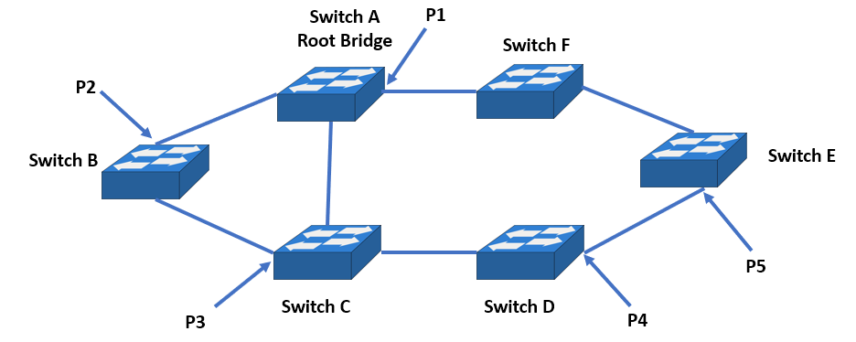

Figure 1: BAB’s Network

1. Spanning tree protocol (STP) is enabled on all switches. Switch A has the lowest Bridge ID, followed by Switch B, Switch C, Switch D, Switch E and Switch F. Switch A is elected as the root bridge.

(i) Fill in Table 1(a)(i) for the identified ports P1 to P5 as root port(s), designated port(s) or blocked port(s).

|  |  |
| --- | --- |
| Port | Port Status |
| P1 | Designated Port |
| P2 | Root Port |
| P3 | Blocked Port |
| P4 | Designated Port |
| P5 | Blocked Port |

Table 1(a)(i): Switch Port Status

(5 marks)

**QUESTION 1** (cont.)

(a)

(ii) Draw the final inter-switch connections after spanning tree protocol has converged.

(3 marks)

|  |
| --- |
|  |

1. You have added a new core switch with a default bridge ID value to BAB’s network in Figure 1. This resulted in a re-election of the root bridge but it may not be the switch of your choice.
2. Describe the process of electing the root bridge.
3. Explain how you would ensure that the new core switch is elected as the root bridge.
4. List the Cisco IOS command line to view the root bridge elected.

(6 marks)

|  |
| --- |
| 1. Every router view itself as the root bridge initially. However, every 2 seconds the routers will send their neighboring routers BUID which consists of their BID and Root ID. If a router sees a lower BID the router with the lower BID will become the root bridge. This change will be reflected in the BUID of router with higher BID. |

**QUESTION 1** (cont.)

1. The new core switch you have added supports multi-switching mode capabilities for an environment which has many transmission errors. The default mode for the switch is cut-through switching.

Explain why cut-through switching mode is not suitable in this environment. Suggest with justification the switching mode you would set for this switch.

(6 marks)

|  |
| --- |
|  |

**QUESTION 2** (30 marks)

Figure 2 below is a network of five routers with the IP addresses of the routers’ interfaces shown. The subnet mask to be used is 255.255.255.0.

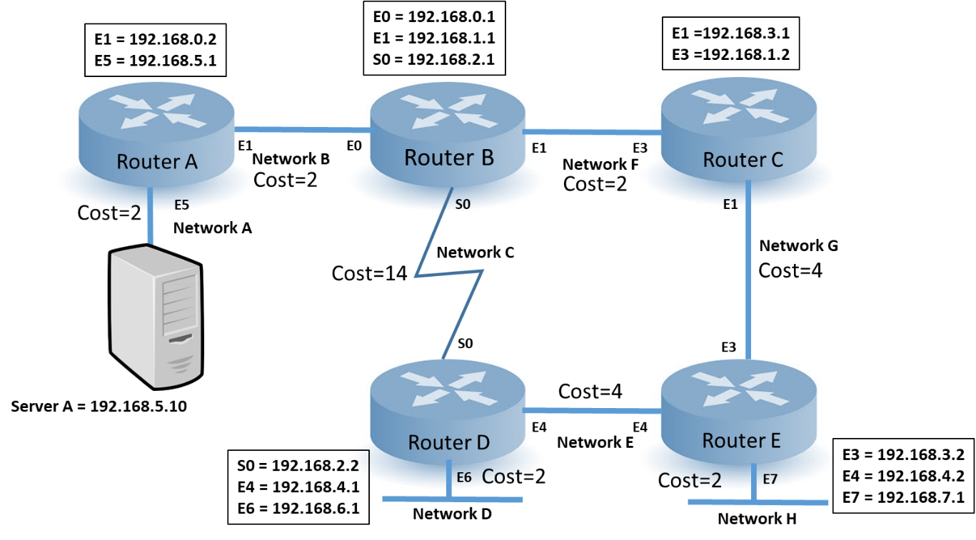

Figure 2: Network of Five Routers

1. Complete the command lines below by filling in the blanks to configure the interfaces of **Router C**.

(4 marks)

RouterC(config)# interface E1

RouterC (config-if)# ip address 192.168.3.1 255.255.255.0

RouterC config)# interface E3

RouterC (config-if)# ip address 192.168.1.2 255.255.255.0

1. Fill in the entries expected to be in the routing table of **Router C** in Table 2(b) after the interfaces are properly configured.

(4 marks)

|  |  |
| --- | --- |
| **Destination Network** | **Next Hop IP Address** |
| 192.168.0.0 | Directly Connected |
| 192.168.3.0 | Directly Connected |

Table 2(b): Routing Table of Router C

**QUESTION 2** (cont.)

1. Complete the command lines below by filling in the blanks to configure static routing on Routers C and B to allow hosts on Network G to access Server A.

(4 marks)

RouterC(config)#ip route 192.168.5.10 255.255.255.0 192.168.1.1

RouterB(config)#ip route  192.168.5.10 255.255.255.0 192.168.0.2

1. Suggest with justification, the most efficient way to configure static route on Router A to allow hosts on Network A to reach all other networks. Write the command line to configure the static route.

(4 marks)

RouterA(config)# int E1

RouterA(config-if)# ip route 192.168.0.1 255.255.255.0 E1

We only configure the static route to router B because network A is a stub network and all data packets coming from outside and going out from network A will have to go through. Hence if we just configure a static route from router A to B, network A can reach all other networks.

DO NOT WANT TO WASTE IP ADDRESS. THUS SUBNET (not related)

**QUESTION 2** (cont.)

1. After configuring the interfaces and static routes on Routers A, B, C and E, hosts on Network G are not able to access Server A. Explain how the following commands can be used to determine the problem(s):

|  |  |
| --- | --- |
| Command | Explanations |
| ping |  |
| show ip interface brief |  |
| show ip route |  |
| show running-config |  |

(8 marks)

**QUESTION 2** (cont.)

1. Describe how a packet originating from a host in Network F is routed to the destination, Server A (IP address 192.168.5.10). Your answer should include explanations on how Router A and B uses their routing tables to route the packet to the destination.

(6 marks)

The Router B will read the packet and look at the packet’s network destination. After identifying the packet’s network destination, it will go through its routing table to check if any of the entries match the packet’s destination. Once it finds Router A, it will send the packet using the next hop address found in it’s routing table Router A entry. As Router A is the packet’s destination address, Router A will check the packet’s dest network ID, and since it is network A, Router A will route the packet to network A which will then deliver the packet to Server A.

**QUESTION 3** (20 marks)

The interfaces on all routers in Figure 2 were correctly configured and static routes were removed.

1. Routing Information Protocol (RIP) is used and the network has reached a state of convergence.
2. Fill in the partial routing table of **Router D** for the destination networks in Table 3(a)(i).

(6 marks)

|  |  |  |  |
| --- | --- | --- | --- |
| **Network** | **Destination**  **Network Address** | **Next Hop IP Address** | **Metric**  **(Hop Count)** |
| **A** | 192.168.5.0 | 192.168.2.1 | 2 |
| **E** | 192.168.4.0 | 192.168.4.2 | 0 |
| **F** | 192.168.1.0 | 192.168.2.1 | 1 |
| **H** | 192.168.7.0 | 192.168.4.2 | 1 |

Table 3(a)(i): Routing Table of Router D

1. A user on **Network D** performs a tracert to Server A. State the routing path taken by the tracert packets, i.e. IP Address(1), IP Address(2), …, IP Address(last).

Explain why this route is taken when RIP is used.

(4 marks)

1. 192.168.6.1
2. 192.168.2.1
3. 192.168.0.2
4. 192.168.5.10

The metric used for RIP is hop count. And this path required the minimum number of hops to go from network D to Server A hence this path of 4 hops was used.

**QUESTION 3** (cont.)

1. Open Shortest Path First Protocol (OSPF) is used instead of RIP and the network has reached a state of convergence.
2. Fill in the partial routing table of **Router D** for the destination networks in Table 3(b)(i).

(3 marks)

|  |  |
| --- | --- |
| **Network** | **Metric (Cost)** |
| **A** | 14 |
| **G** | 4 |
| **H** | 6 |

Table 3(b)(i): Routing Table of Router D

(ii) The user on Network D performs a tracert to the Server A. Explain why a different routing path is taken when OSPF is used instead of RIP.

(3 marks)

The metric used for OSPF is speed, reliability, and other factors while the metric used for RIP is hop count. Hence, OSPF does not care how many hops it takes but rather cares about finding the path that gives it the best results in terms of its own metrics.

(c) State TWO advantages of using OSPF routing protocol over RIP routing protocol.

1. marks)

|  |
| --- |
|  |

**QUESTION 4** (30 marks)

A food delivery company, ATS is setting up an office in a 3-storey self-owned building. The company has three departments, namely Sales, Admin and Finance. Each department is located on one level and has less than 50 staff. The staff need to have network access to the resources within the entire building. On each level, there is a shared network printer, a wireless access point and a room to house a switch. In addition, on level 1, there is another room to house three servers, a switch and a router. Due to the electrical riser and cabling layout tray in the building, the data cabling via the electrical riser and cabling tray must be non-susceptible to magnetic interference.

1. Draw a structured cabling diagram for the above to meet ATS data communication requirements. The diagram should be clearly labelled to illustrate the following:
2. Structured Cabling Subsystems,
3. Structured Cabling Connecting Components and
4. Types of Ethernet PHY Connections.

(12 marks)

|  |
| --- |
|  |

**QUESTION 4** (cont.)

1. ATS subscribed to an ISP and was assigned with a Class C Network ID of 201.20.100.0. As the network administrator, you are tasked to provide an IP addressing scheme for the required departments. Each department will have no more than 50 hosts.

**[Assume that subnet zero and subnet all ones are allowed]**

1. Determine the new subnet mask required for the new IP addressing scheme. All working must be clearly shown.

(3 marks)

|  |
| --- |
| If max host per department is 50, then if the network component borrows 2 bits, there will be 2^6 – 2 = 62 usable host. If 3 bits were borrowed there will be 2^6 -2 = 30 usable host which would be less than 50 and hence wrong. Thus 2 bits is the minimum bits that can be borrowed  New subnet mask = 255.255.255.192 / 210.20.100.0/26 |

(ii) Determine the maximum number of hosts per subnet. All working must be clearly shown.

(2 marks)

|  |
| --- |
| Last octet of subnet mask = 1100 0000  Number of host bits = 6  Max host per subnet = 2 ^ 5 – 2 = 62 |

(iii) Determine the 1st, 2nd and 3th usable subnets and their IP address ranges to complete Table 4(b)(iii).

(9 marks)

|  |  |  |  |
| --- | --- | --- | --- |
|  | Network ID (201.20.100.0) | Subnet Bits | Host IP Range |
| 1st Usable Subnet | 201.20.100.0 | 00 | 201.20.100.1 to 201.20.100.62 |
| 2nd Usable Subnet | 201.20.100.64 | 01 | 201.20.100.65 to 201.20.100.126 |
| 3rd Usable Subnet | 201.20.100.128 | 10 | 201.20.100.129 to  201.20.100.190 |

Table 4(b)(iii): Usable Subnets

**QUESTION 4** (cont.)

(iv) After creating the above subnet manually, you configured a static IP address of 201.20.100.200 on a PC. Determine the subnet it belongs to and the broadcast address. All working must be clearly shown.

(4 marks)

|  |
| --- |
| 1. .0 2. .64 3. .128 4. .192   From here, 201.20.100.200 belongs to the subnet with network ID of 201.20.100.192. This is because 200 is more than 192 hence meaning it must be in the .192 subnet. It’s broadcast address will be 201.20.100.255 |

** END OF PAPER **